AIM:-

Arduino Controlled Bulb Using PIR Sensor ( HC-SR01 )

APPARATUS REQUIRED:-

* Arduino
* PIR Motion Sensor
* Relay Module
* Bulb
* Jumper Cables

THEORY:-

Arduino:-

Arduino is an open-source electronics platform based on easy-to-use hardware and software. [Arduino boards](https://www.arduino.cc/en/Main/Products) are able to read inputs - light on a sensor, a finger on a button, or a Twitter message - and turn it into an output - activating a motor, turning on an LED, publishing something online. You can tell your board what to do by sending a set of instructions to the microcontroller on the board. To do so you use the [Arduino programming language](https://www.arduino.cc/en/Reference/HomePage) (based on [Wiring](http://wiring.org.co/)), and [the Arduino Software (IDE)](https://www.arduino.cc/en/Main/Software), based on [Processing](https://processing.org/).

PIR Sensor:-

The HC-SR01 actually works by detecting the infrared rays. Whenever the human body comes near motion sensor so as the human body emits infrared rays, the motion sensor detects this infrared rays and it gives us a HIGH signal though the output pin.

Relay Module:-

The relay module is a separate hardware device used for remote device switching. With it you can remotely control devices over a network or the Internet. ... Individual LED's on the front panel monitor the input and two relay lines. The module is powered with an AC adapter.

Further Working After PIR Sensor:-

This HIGH signal is then read by the Arduino. So if Arduino reads a HIGH signal, it will give a HIGH signal to the relay module which means that the relay will turn on and as a result the light bulb will glow. Similarly if the Arduino reads a LOW signal, it will make the relay pin LOW and as a result the light bulb will remain low.

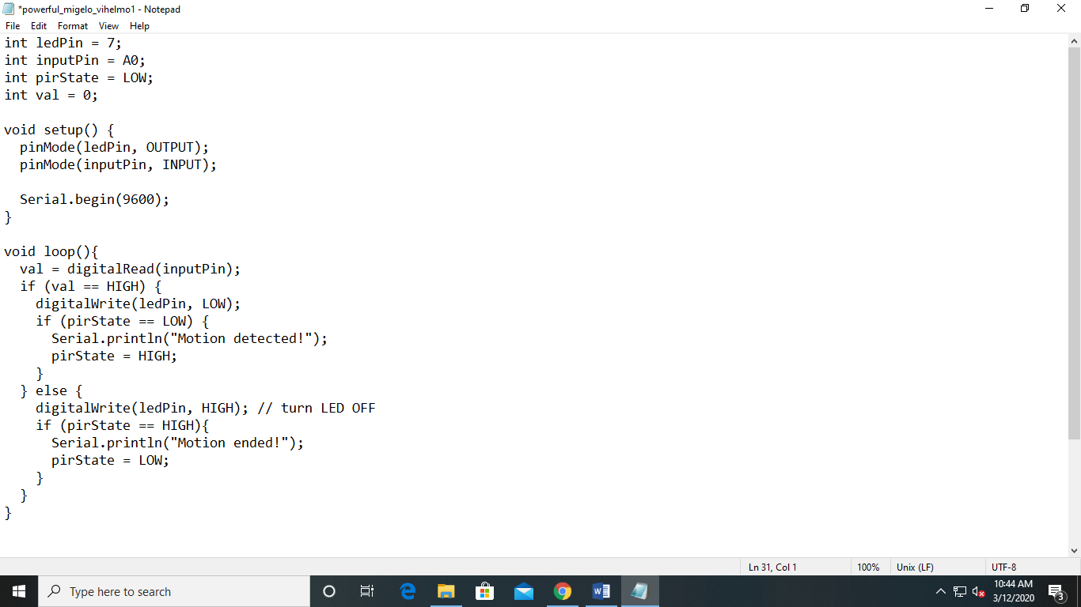Code:-

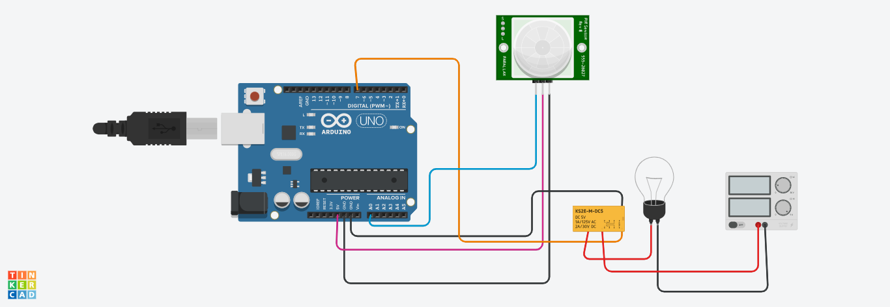Circuit:-

**PIR SENSOR**

**ARDUINO**

**RELAY**

**POWER SUPPLY**

**BULB**